For Immediate release:
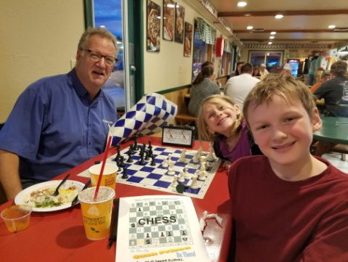
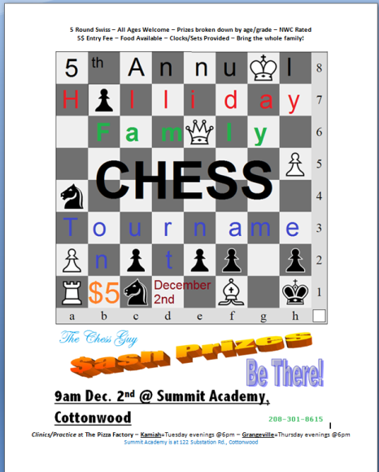
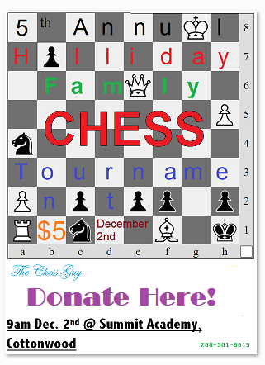
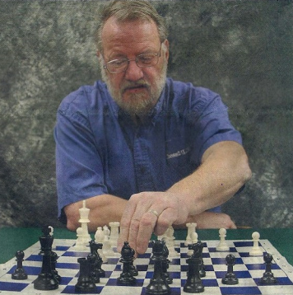
Sandy Staab, The Chess Guy, will be visiting 32 businesses in the Palouse valley area distributing donation jars and posters promoting the 5th Annual Kamiah Family Chess Tournament. Donations will be solicited for tournament prizes from businesses in the form of cash or otherwise. The Donation Jars give the community a chance to support this kid-centered family-friendly event as well.
The Chess Guy will also be giving free chess instruction at both the Kamiah (Tuesdays at 6pm) and Grangeville (Thursdays at 6pm) Pizza Factories up to the time of the tournament.
The Chess Guy encourages interested families to come enjoy some pizza and learn how to play chess, improve your game, or just hang out and play. Sets and clocks will be provided.
The Chess Guy will also be visiting local schools to promote the tournament and offer free instruction to students.
The tournament will be held on December 2nd 2017 from 9am to 3pm at Summit Academy located at 122 Substation Road near Cottonwood. There is a $5 entrance fee for players and all ages are welcome to play. Food will be available at the tournament but you can bring your own lunch as well.
Sets and clocks will be provided but if players have a tournament grade Staunton design chess set they are encouraged to bring them as we may have more students this year than The Chess Guy has sets! Tournament grade student sets will be available for purchase as well at $20 each.
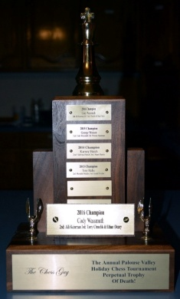
Each year the tournament has had more support either financially or in numbers attending, despite the snow over the past 2 years! Last year we had record donations that allowed us to give a generous $100 first prize gift and many other cash prizes. Prizes are awarded by age group so there is ample opportunity for any participant to win.
The top winner will have his/her name added to the perpetual Chess Trophy of Death.
The Chess Guy wishes to thank all donors in the past and The Pizza Factory for its strong support. Chess is the classic strategy game of kings and has been shown to improve player’s academic performance and social skills.
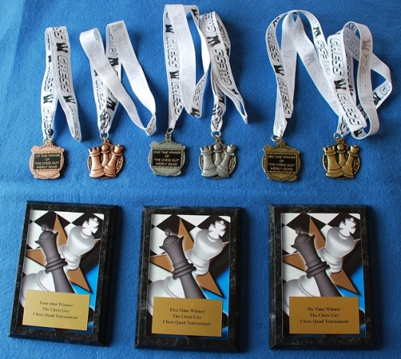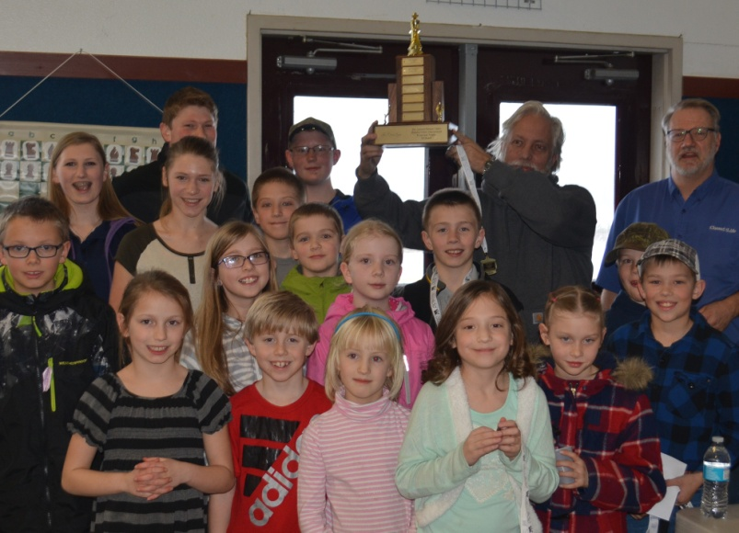
The Chess Guy can be contacted at SandyTheChessGuy@gmail.com or at 208-301-8615. His website is at http://SandyTheChessGuy.weebly.com and his facebook page is at http://facebook.com/TheChessGuy
