Attend the
6th Annual Holiday Family
Chess Tournament
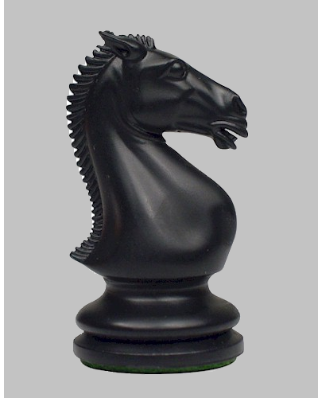
Saturday, January 5th at Summit Academy in Cottonwood
Starts at 9AM Entrance Fee: $10 Scholastically Rated
Ages 6-adult are Welcome
Prizes for 1-3rd place for Adults and grades 1-3,4-6,7-9,10-12.
http://sandythechessguy.weebly.com/
Meet The Chess Guy evenings at these places for free coaching:
Mon:Kooskia China Café, Tue:Orofino Pizza Factory, Wed:Grangeville Pizza Factory,
Thr:Kamiah Pizza Factory, Fri:Cottonwood The Hangout

