***2nd Annual* Holiday Family Chess Tournament**

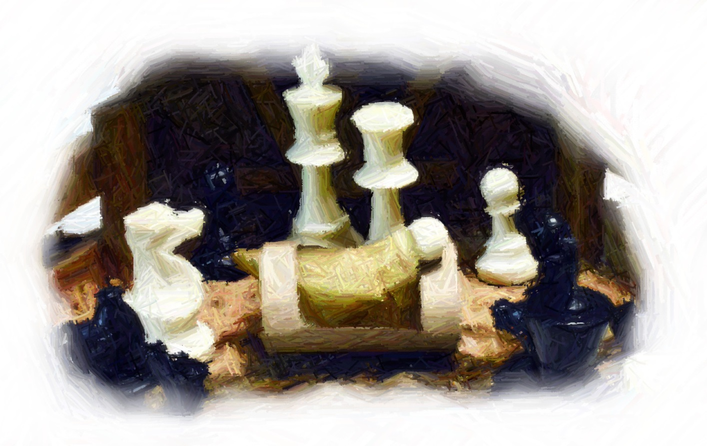

**At the Kamiah Welcome Center in Kamiah**

**Saturday December 27th, 2014**

**Open to all ages**

**$7/person fee – Prizes galore!**

**9AM – 10AM – Free chess instruction for newcomers.**

**10AM-3PM – Tournament**

**30 min. break for lunch – BYOL, Scholastically rated**

The Chess Guy

[SandyTheChessGuy@gmail.com](mailto:SandyTheChessGuy@gmail.com) 208-926-4450