5 Round Swiss – All Ages Welcome – Prizes broken down by age/grade – NWC Rated
5$ Entry Fee – Food Available – Clocks/Sets Provided – Bring the whole family!

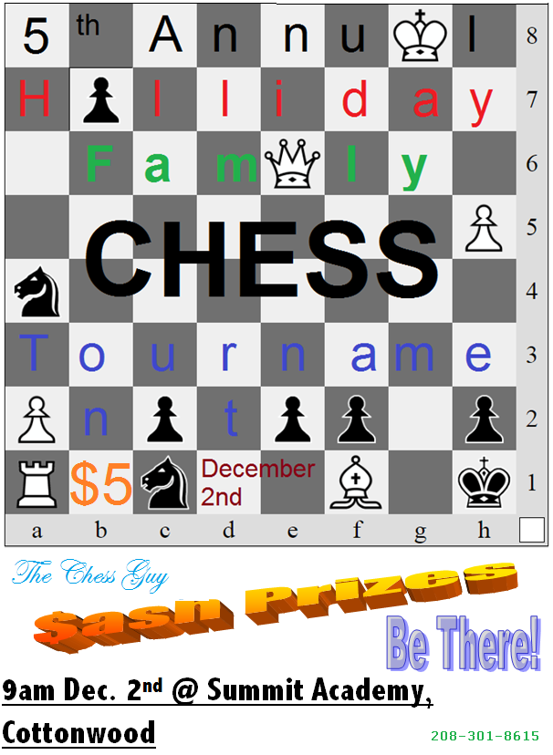
Clinics/Practice at The Pizza Factory – Kamiah=Tuesday evenings @6pm – Grangeville=Thursday evenings @6pm
Summit Academy is at 122 Substation Rd., Cottonwood

